Week in Review - May 3-9
Alex Shvartsman

PRO TOUR: BARCELONA
Pro Tour: Barcelona winner Kai Budde set all kinds of records. He is the first person to ever win three Pro Tours. He is the first to ever win two Pro Tours in the same season. He is 9-0 in Pro Tour Top 8 matches. He will likely become the first to earn Player of the Year title twice.
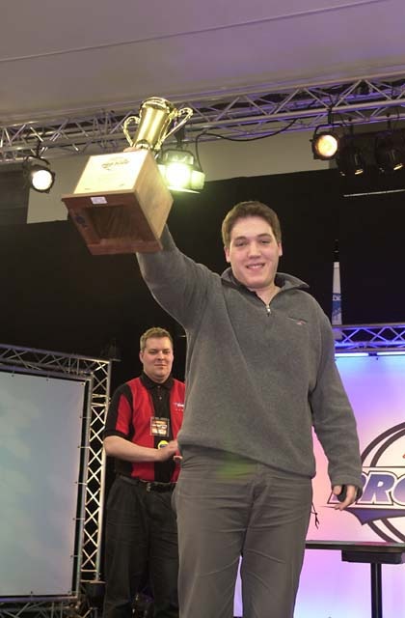
In my eyes, those achievements pale compared to how good a friend he can be.
Kai faced his friend and roommate Patrick Mello in the Top 4. Having won their match, Budde asked for Tournament Manager Jeff Donais, and asked his permission to concede the match to Mello.
His reasons? "Patrick needs the pro points more than I do, to get on the Masters Series. He also probably has a better chance in the finals." Budde was willing to forgo the chance to set all the records he did, in order to help a friend.
He went about it the right way, too. They played out the match first, so there could be no possibility of collusion. Having been there, covering the match for Sideboard, I am sure that both played their hardest to win. Only after concluding the match did Budde make his request.
His request was denied. Understandably, Wizards of the Coast does not want players throwing matches to each other during the single elimination rounds of major tournaments. Budde went on to defeat Alan Comer in the finals, despite the bad matchup - but the story will be remembered longer than most records set by Budde will stand.
Barcelona saw two new countries represented in PT Top 8 - Ukraine's rookie Yuri Kolomeyko and Singapore pro Albertus Law both made it to the single elimination rounds, joined by American first-time top finishers Brad Swan and Chad Ellis.
Jon Finkel and Kamiel Cornelissen are continuing to go head to head, to determine who is the second best player on the Tour currently. Both finished in the Top 16, though Finkel picked up more cash than Cornelissen at the Masters.
Former Player of the Year point leader Mike Pustilnik lost his dominance, despite a strong finish in Barcelona. He is now tied for second with Kamiel Cornelissen at 66 points each. Kai Budde is in a very strong lead with 82 points. Tied for fourth are Ryan Fuller and Scott Johns, at 55 points each, with Zvi Mowshowitz just one more point behind at 54. Only a handful of team GPs and the World Championships remain to alter these standings.

BARCELONA MASTERS SERIES
A total of five archetypes saw play in Barcelona Masters. B-U, R-G, R-B, GoMar and Domain where the only decks considered good enough to play by the Pros. Domain won out, with nine competitors utilizing that strategy. The most rogue deck was U-B. with only three players using it.
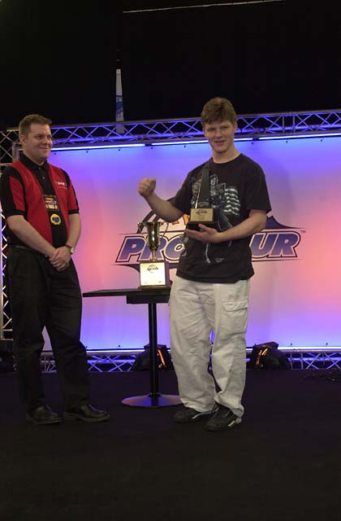
Superman takes his second Masters... but can he stay on the gravy train?
In the end it was Ben Rubin who took home the prize, defeating Jay Elarar in the finals. Rubin has been having some really bad luck on the Pro Tour lately - he hasn't played in Day 2 of an individual Pro Tour this season and faces a real chance of falling off the gravy train, let alone Masters Series, without a solid finish at Worlds. His Masters performance, on the other hand, has been stellar. The only player to win Masters twice, many a player at the top of the pro point standings would trade places with him for the $50,000 in prize money Rubin accumulated this year. To paraphrase Jon Finkel, "cash winnings are the only relevant point system to keep track of player's performance with."
Invasion Block Constructed will resurface as a format late this summer. Having added Apocalypse to the mix, players will use IBC decks to compete for invitations to Pro Tour: New Orleans.

MILE HIGH CLUB
I was honored to participate in a first-ever sanctioned booster draft held in flight, while crossing the Atlantic Ocean.
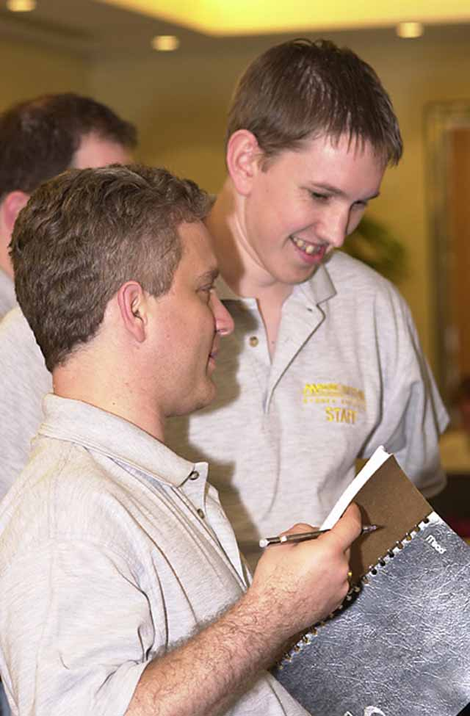
Paul 'Red Baron' Barclay presided over the draft
A Delta flight returning from Barcelona to New York City on Monday afternoon was packed with Magic players and Wizards of the Coast staff such as Omeed Dariani, Randy Buehler, Chris Galvin, and Paul Barclay. Along for the ride, several hundred pro points worth of PT Barcelona competitors.
Any time there are four or more players on a flight, a possibility of a draft arises. With so many players there, it was more of a certainty. And when Paul Barclay informed us that he could sanction a draft if we chose, it became a definite reality - most players were excited to take place in the first ever in-flight draft.
We traded seats and searched out some packs and basic land for a while. Eventually, eight players were sitting relatively close to each other, able to pass the packs down the aisles. The table was definitely Pro Tour quality. It featured players such as Brian Davis, Tom Swan, Brock Parker, Brian Kibler and yours truly. Team ABU's Mike Thompson won the historic event, defeating Kibler in the finals. My own deck was poor enough for me to be happy about the draft being ran as single elimination.
There was brief talk of sanctioning a small Constructed tournament as well, but few players brought Constructed decks in their carry-on luggage. Perhaps it might pay to start carrying your Standard deck with you. You never know when Paul Barclay might be on your flight, sanctioning a Standard tournament.

COMING UP: GRAND PRIX YOKOHAMA

Very near Tokyo, Yokohama hosted the 1999 World Championship. Magic is back in this large Japanese port city, with the first in a series of Team Grand Prix qualifiers for TPT New York.
Team format is popular in Japan, so the organizers expect a good turnout. International teams expected to attend include Ryan Funner-Chris Benafel-David Williams and Rob Dougherty-Mike Pustilnik-Alex Shvartsman. Others, including Bob Maher, are considering making last-minute travel plans, so tune in to Sideboard coverage this weekend to find out who shows up.

MAGIC TRIVIA
Last week's question:
You are playing a game of Masques-Nemesis-Prophecy booster draft. Neither player cast anything during the first three turns. On the fourth turn, you play a land and tap all four mana into your mana pool... At the end of your turn, there are two 5/5 creatures and a 3/3 creature in play. How did this happen?
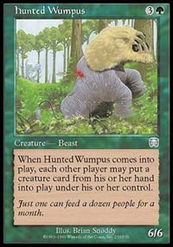
This trivia is based on a real game situation involving French pro player Marc Hernandez. On the fourth turn of the game, Marc cast a Hunted Wumpus. His opponent dropped his own Hunted Wumpus, and Hernandez put an Ascendant Evincar into play. Evincar gave each Wumpus -1/-1, with a grand total of two 5/5 and one 3/3 creatures in play.
There are a number of other viable solutions. For example, a player could cast Charmed Griffin, with his opponent putting a Saproling Burst into play and making two Saproling tokens at the end of turn.
New question:
Urza Planeswalker is one of the key characters in current Magic storyline. What popular TV show featured a minor character named Urza?
Please do not email me your answers. The correct answer will be posted in next week's column.

PLAY OF THE WEEK
I was unfortunate enough to be on the receiving end of this one.
It is round two of Pro Tour: Barcelona. I am 1-0 and get paired against Finnish pro Tuomo Nieminen. Here is the recap of our entire first game:
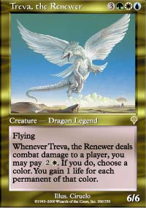
Tuomo: Island
Me: Forest
Tuomo: Forest
Me: Forest
Tuomo: Swamp
Me: Mountain, cast Amphibious Kavu
Tuomo: Plains
Me: Attack for two. Mountain. Cast Sparkcaster and gate Kavu back to my hand.
Tuomo: Mountain. Use Rushing River without kicker to bounce my Sparkcaster.
Me: Recast the Kavu.
Tuomo: Play land #6. Cast Crosis, the Purger.
Me: Frown, attack for 2. Recast Sparkcaster.
Tuomo: Cast Treva the Renewer.
With two more lands of any kind, Nieminen could have won with Coalition Victory! Of course he did not play any bad cards like that - his two Dragons finished me off all on their own. I got to meet Treva again in game 2, with a shockingly similar result.
As always, please send good/bad plays, cool trivia questions, and other news to ashv@concentric.net.

